ST RICHARD’S HOSPICE
JOB DESCRIPTION

Job Title: Integrated Community Services Administrator
Responsible to: Community Nurse Manager
Accountable to: Director of Clinical Operations

Values

Our Core Values underpin everything we do and all employees are expected to comply with our Values and reflect these in their day-to-day work.
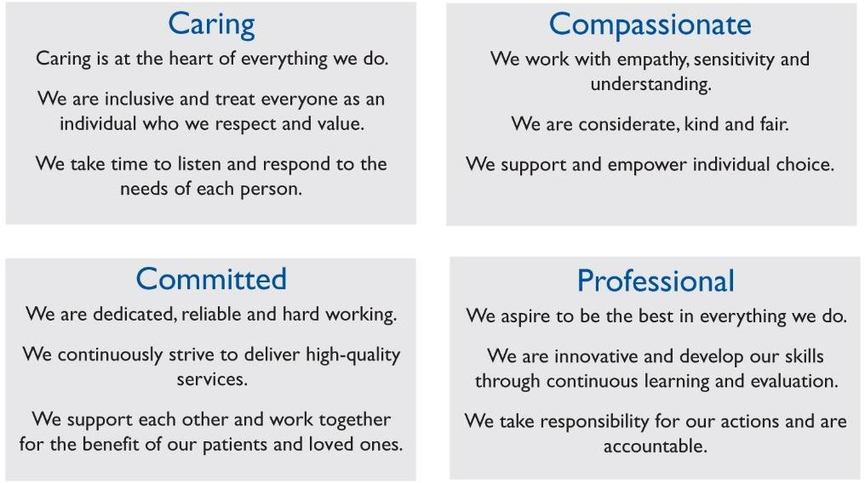

Job Summary: To provide a responsive administration service to facilitate the smooth running of the following patient services:

- Integrated Community Services
- In-patient Unit

The post holder will be required to work flexibly in conjunction with other administrative staff to ensure that all departments are able to function efficiently, providing cover for other services if required. The role requires working in various offices within the hospice.

Main Duties and Responsibilities: -

- To work with the other clinical administrators, Personal Assistant (PA) to Clinical Directors and administrative volunteers to provide comprehensive data entry and administrative service to Patient and Family Services Departments, as required.
- To use SystmOne, Bluespier, Microsoft applications (including but not limited to outlook, word and excel), NHS.net emails and any other digital applications/platforms to facilitate efficient and accurate administration of patient/family records.
- To record events and consultations for Patient and Family Services departments as required.
- To scan documentation into patient/family records as necessary.
- To produce template letters via SystmOne
- To provide absence cover for other members of the administration team, as required.
- To organise and prioritise own work schedule using initiative.
- To maintain complete confidentiality in all areas of work both within the hospice and within the public domain.
- To transcribe clinic letters using electronic systems, as required.
- To attend MDT meetings and team meetings and minute electronically.
- To minute/attend other meetings as required.
- To receive telephone calls from a wide range of stakeholders including health care professionals, patients, families and clients and action and signpost as appropriate.
- To use electronic systems to ensure timely communication and handover to all team members.
- To be flexible to assist the wider administration team and ensure continuity in the event of absence of colleagues.
- To receive and provide information in a strictly confidential and professional manner, including handling post and telephone calls, escalating as appropriate
- To keep all team communications (such as team diary and external communications) up to date

Education and Learning

- To maintain own personal development by attending appropriate courses and updates to maintain and develop skills and expertise

- To participate in the Individual Performance Review (IPR) process and respond to the agreed development plan

- To undertake statutory, mandatory and role enhancement training as directed

- Carry out any additional learning/training relevant to role and if required for any link role

General responsibilities of all clinical staff

Confidentiality

All employees must maintain confidentiality of information relating to;
- Personal information about our patients, their families and carers.
- Personal information about individuals who are supporters or otherwise
involved in the activities organised by St Richard’s Hospice.
- Information about the internal business of St Richard’s Hospice.
- Personal information about colleagues working for St Richard’s Hospice.
Employees must only use the information you have been authorised to use and for the purposes that have been authorised.

Information Governance

All staff are required to comply with all relevant legislation. Staff should be aware that they may be held personally accountable for any breaches of information security for which they may be held responsible.
All staff who process and has access to St Richard’s documents and records is responsible for ensuring that they act in accordance with the relevant policies, standards guidance and procedures. They also have responsibility to complete any required training or provide evidence of training.

Training and Development
All staff will ensure they are up to date with the required statutory and mandatory learning for their role. Employees should regularly review their learning record on iConnect, identify when an update is required, and agree with their line manager when this will be undertaken.

All staff have a responsibility to participate in Individual Performance Reviews (IPR). IPR is a means of two-way communication which helps to ensure that the service provided by the Hospice maintains a high-quality standard, whilst

helping staff to be properly equipped for their present or future roles within the Hospice.

Safeguarding
All staff are responsible at work to encourage a culture which embraces safeguarding the welfare of children, young people and vulnerable adults for whom they are responsible for or may come into contact with in the job role.

Infection control

All staff who are in direct contact with patients/clients have a responsibility to observe the precautions outlined in the Infection Control policy, to prevent further spread of infection thereby protecting patients and staff.

Equality Diversity and Inclusion

Staff at all levels have responsibility to comply with the Equality, Diversity and Inclusion Policy and treat others with respect and dignity. The personal commitment of everyone to the policy and the application of its principles are essential to eliminate discrimination and provide equality and equity throughout the organisation.

Health and Safety

St Richard’s Hospice is committed to ensuring, so far as is reasonably practicable, the health safety and welfare of staff, volunteers and patients, together with those that may be affected by our activities.
All staff have a responsibility to promote a positive Health and Safety culture within the organisation and seek guidance from the line manager if unsure about any issues relating to health and safety.

Job Description

This job description is not exhaustive, and duties may be reviewed from time to time and revised and updated in consultation with you.

In addition to the above, all staff must undertake to familiarise themselves with
and comply with all St Richard’s policies relevant to their role.

Signed…………………………………………………Date……………………………….

ST RICHARD’S HOSPICE

PERSON SPECIFICATION

Job title: Integrated Community Services Administrator Responsible to: Community Nurse Manager
Accountable to: Director of Clinical Operations

 | Essential | Desirable
Education, Qualifications and Training | A good level of maths, English and general ICT skills (at least GCSE  Grade 4/C or above - or equivalent) | A relevant business or administrative qualification  Relevant typing qualification
Experience/Knowledge | Proven experience in a clinical administration role ideally within a hospice, palliative care, NHS or healthcare setting | Experience of working in multi-disciplinary teams
Skills and Abilities | Practical working knowledge of SystmOne Electronic Patient Record System or other Electronic Patient Record system  Excellent Microsoft Office skills including Excel  Effective time management and organisational skills  Initiative to work independently with minimal supervision after induction  Able to identify priorities within a demanding, and often reactive, workload and sustain consistent quality performance when under pressure  Excellent communication skills (both oral and written)  and an ability to relate to a wide range of people including over the telephone.  High level of accuracy, attention to detail and commitment to confidentiality  Ability to work as part of a team | Ability to use Bluespier
Personal Qualities and Aptitudes | Professional, caring, compassionate and committed.  Flexible with new ways of working  Understands the emotional context of hospice care and works with empathy and resilience | Ability to be innovative  Awareness of strategies for self- care

