ST RICHARD’S HOSPICE
JOB DESCRIPTION

Job Title: Warehouse Driver
Responsible to: Furniture & Transport Manager
Accountable to: Warehouse Manager

Our Values:

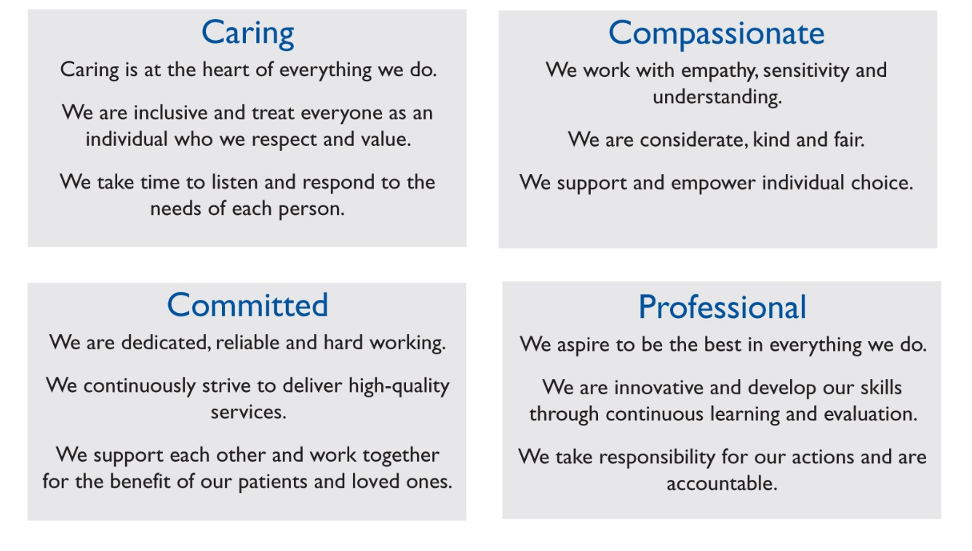

Job Summary
The driver will be responsible to collect and deliver items of donated furniture and also collect and deliver donated stock from all of our charity shops using the Hospice Vehicles. The post holder will also provide general assistance to the Line manager within our warehouse and furniture shops.

Main Duties and Responsibilities
  - To plan the working day in order to maximise collections and deliveries and the economical use of the Hospice transport

  - To collect and deliver items as requested by donors or customers

  - To collect and deliver donated stock as requested by our team of shop managers

  - To complete the appropriate Gift Aid paperwork and also sign new donors up

  - To decide on the quality and suitability of furniture before acceptance, and to be aware of the guidelines issued by the department of health & safety and trading standards

  - To maintain a textile bank collection service throughout Worcestershire in line with current practices

  - To complete daily food runs from our hospice to our cafe located in Worcester city centre and any other hospice related requirements

  - To carry out any other duties as directed by your line manager both at the warehouse and at our furniture shops

  - You will be responsible as a paid employee for security within the shops and any property of St Richard’s Hospice Foundation and should report any security issues to the line Manager

  - To ensure that any voluntary van drivers and drivers’ mates are appropriately trained in any given task

  - To regularly check the vehicle before use and report any defects, to follow service schedules and book accordingly, also to keep the vehicles in a good clean state

  - To maintain logs of collections and deliveries and record daily mileages
General
  - The driver should always be of presentable appearance, and conduct themselves in a manner that presents a favourable image of the Hospice to the general public

  - Tact and diplomacy will be exercised at all times when having to refuse donations, and the reasons explained to the donor

  - Be aware of the responsibilities placed on employees under the Health and Safety at Work Act, to maintain a safe environment for employees and visitors

  - Ensure equal opportunities is put into practice in all aspects of work in accordance with the Hospice policy and procedures

  - All information concerning patients/clients and staff must be treated as strictly confidential at all times

All staff are required to abide by St Richard’s Hospice policies and procedures, including confidentiality, equal opportunities and data protection
This job description is not exhaustive and may be reviewed on agreement of the post holder and Line Manager

Signed……………………………………………………Date………………………………..

