

ST RICHARD’S HOSPICE JOB DESCRIPTION

Title: Shop Manager - Bank

Reporting to: Regional Manager

Accountable to: Associate Director of Retail Operations

Our Values:
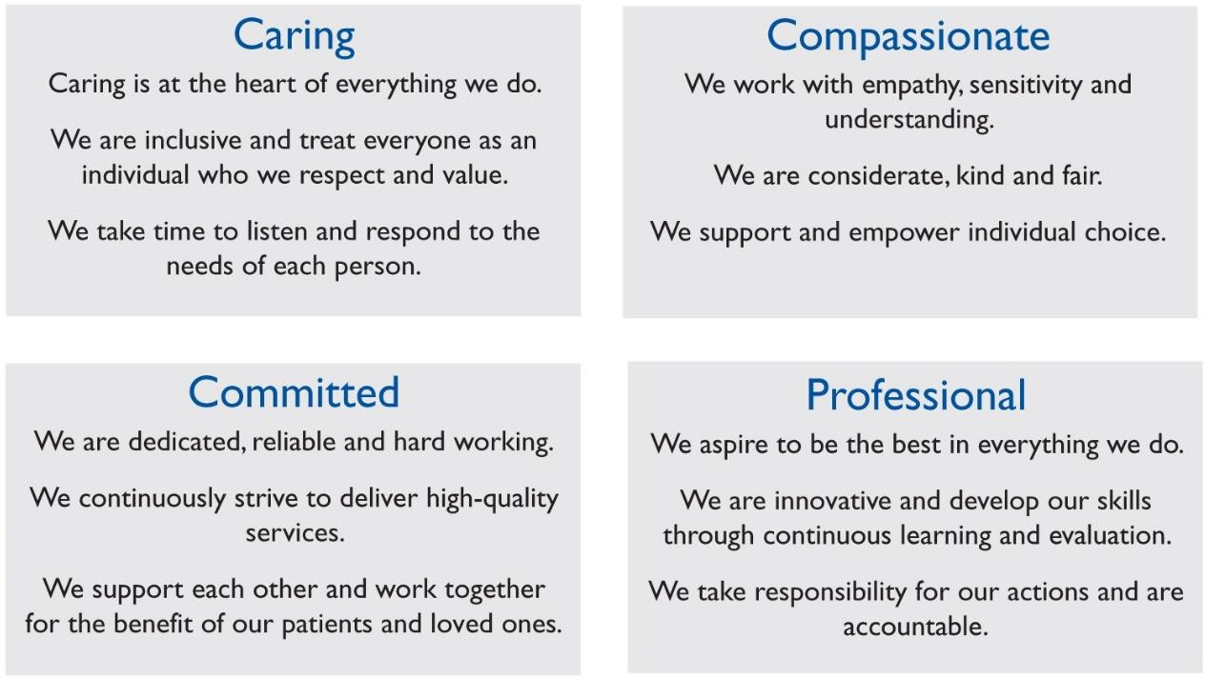
Job summary:

To provide effective management in the efficient running of our retail shop. To be responsible for all activities at the Shop, such as Volunteer recruitment and training, maintaining stock levels, sorting and pricing, stock movement and visual merchandising.

Principal Duties & Responsibilities:
  - To recruit, manage, motivate and train volunteers to ensure the smooth running of the shop and implement new ideas with a positive attitude.

  - To inform the Regional Manager of any problems relating to the welfare of our volunteers, and to be aware of the value of

volunteers, who give their time willingly for the benefit of the Hospice.

  - To allocate your time to ensure that maximum trading time and cover is achieved.

  - To be flexible with your time to cover times required to maximise trading hours.

  - To be aware that certain donated goods may be of considerable value, and to secure these goods until they have been professionally valued.

  - To ensure that goods are presented in a way that maintains the high standard and quality customers have come to expect from St. Richard’s Hospice shops.

  - To encourage and sign up donors to our Gift Aid scheme.

  - To ensure that all returns and paperwork are submitted to Head Office accurately and in appropriate timescales.

  - To hold regular meetings with the Shops & Commercial Director and the Regional Manager to discuss ways of improving shop sales and how we may utilise the many qualities of willing volunteers in other activities.

  - To attend any meetings, training or conference that has relevance to your position and your day to day work.

  - To undertake any other reasonable duties as and when required by the Shops & Commercial Director and Regional Manager.

  - To undertake annual IPR with the Shops Manager or Director as appropriate, and respond to the agreed development plan in personal development.

Health & Safety

  - To attend mandatory updates on fire and safety, moving and handling etc.

  - To be aware of the responsibilities placed on employees under the Health and Safety at Work Act, to maintain a safe environment for employees and visitors.

  - To bring concerns to the attention of the Management
Signed ………………………………………. Date……………………….

